**(_Club) – Child Safeguarding Policy**

**Effective Date**: [Insert Date]  
**Review Date**: Annually or as required  
**Approved by**: (_Club Committee / Board)

**1. Purpose**

(_Club) is committed to creating a safe, supportive and inclusive environment for children and young people. This policy outlines how we protect children in our care in line with Western Australian legislation and best-practice guidelines including the Football Australia Safeguarding Policy, National Principles for Child Safe Organisations, and other resources designed to inform, educate and empower both children and adults.

**2. Scope**

This policy applies to all (_Club) members, including committee members, coaches, managers, volunteers, players, families, and visitors participating in any club-related activity.

**3. Guiding Framework**

This policy draws on the following key resources:

* Football Australia Member Protection Framework
* Football Australia Safeguarding Policy
* Football Australia Code of Conduct and Ethics
* Football Australia Complaints Procedure
* Football West Code of Conduct
* Western Australia Working with Children Check Policy & Legislation
* National Principles for Child Safe Organisations – [Australian Human Rights Commission]
* Child Safe Practices Booklet – [SIA]
* Health Direct Child Abuse Information – [Health Direct Australia]
* Child Safeguarding in Sport Induction – [SIA]
* Child Safeguarding Risk Management Framework – [SIA]
* Your Rights at Sport (7–12 years) and How Your Sport Looks After Kids – [SIA kid-friendly resources]
* Speak Up & Make a Complaint – [National Office for Child Safety]
* Making an Integrity Complaint or Report – [SIA]
* Pre-employment screening: WWCC and Police Checks – [Australian Institute of Family Studies (AIFS)]

**4. Legal Obligations**

(_Club) adheres to relevant legislation in Western Australia, including:

* *Children and Community Services Act 2004 (WA)*
* *Working with Children (Criminal Record Checking) Act 2004 (WA)*
* *Equal Opportunity Act 1984 (WA)*

All adults in child-related roles must comply with the WA Working with Children Check (WWCC) requirements.

**5. Roles & Responsibilities**

**5.1 Club Officials and Volunteers**

* Must complete WWCC unless exempt (e.g. parent volunteer working only with their own child)
* Must provide WWCC and police check evidence to the (_Club) Secretary before commencing duties
* Must complete the (SIA) Safeguarding Children and Young People in Sport Induction online eLearning module
* Must understand and comply with this Child Safeguarding Policy

**5.2 Parents and Guardians**

* Are required to be responsible for the supervision of their children under 10 years old during matches and training. This includes players and their siblings. This responsibility does not lie with the team coach, team manager or other club volunteer during club activities. Where a parent is nominating supervision or their child by an alternate guardian, the coach and/or team manager is to be notified
* Are encouraged to discuss safety, respect and support with their children and club officials
* Should familiarise themselves with the How Your Sport Looks After Kids and Your Rights at Sport resources (SIA)

**5.3 Coaches and Managers**

* Must model appropriate behaviour as per the Football West Code of Conduct
* Must understand protective behaviours, grooming, and boundary violations
* Must avoid one-on-one situations and maintain open, transparent relationships with players
* Are required to report any safeguarding concerns or disclosures immediately

**5.4 Players**

* Junior players old than 10 should be partnered with players of similar age when being parted from their training/team group to use amenities, canteen, equipment storage areas or other similar requirements. Coaches, managers, or other responsible guardians should implement this requirement for these or other similar activities. Visibility of children to attend amenities, canteen and/or equipment areas should be considered carefully, including time of day and appropriate access, other safety concerns, security and lighting to these areas.

**6. Working With Children Checks (WWCC) and Screening**

**6.1 Requirements**

(_Cub) applies rigorous screening, in line with AIFS recommendation

* All relevant adults and pad employees must hold a WWCC unless legally exempt
* Police checks for relevant positions in line with AIFS recommendations
* Recording all checks in a club WWCC Register

**6.2 Exemptions**

Certain people do not require a WWC Check because they fit within the description of an exemption from child-related work as outlined in the Working with Children (Screening) Act 2004 and the Working with Children (Screening) Regulations 2005.

There are some general exemptions which apply across all categories of child-related work while others are specific to a particular category or circumstance.

If a person’s work is covered by an 'exemption', then they are ineligible to apply for a WWC Check. However, it is important to consider all the work a person does when deciding whether they are exempt and do not require a WWC Check

**7. Code of Conduct**

(_Club) adopts the Football West Code of Conduct and enforces behaviour expectations through:

* Clear guidance for interaction with children, including treating children with dignity and respect
* Two-adult rule for supervision
* No private messaging or gifts to individual children
* No favouritism, isolation, or inappropriate physical contact
* Avoiding private communication with minors

**8. Education and Awareness**

(_Club) encourages continual learning and understanding through:

* Safeguarding Children and Young People in Sport Induction (SIA)
* Child Safe Practices Booklet
* Protective Behaviours in Sport Animation
* Access to Your Rights at Sport (7–12 years) and How Your Sport Looks After Kids resources
* Parental guidance to report abuse through Health Direct or Child Protection services

**9. Risk Management**

(_Club) implements the Football West Child Safeguarding Risk Management Framework and:

* Conducts safety reviews for all club environments
* Ensures visibility in training, transport and change rooms
* Keep change rooms and amenities monitored while preserving privacy
* Avoids situations where a child is left alone with a single adult
* Considers specific needs of children from diverse backgrounds
* Provide safe communication and complaint options for children

**10. Responding to Concerns**

**10.1 Complaints Process**

The following flow chart should be following when lodging a complaint with (_Club):

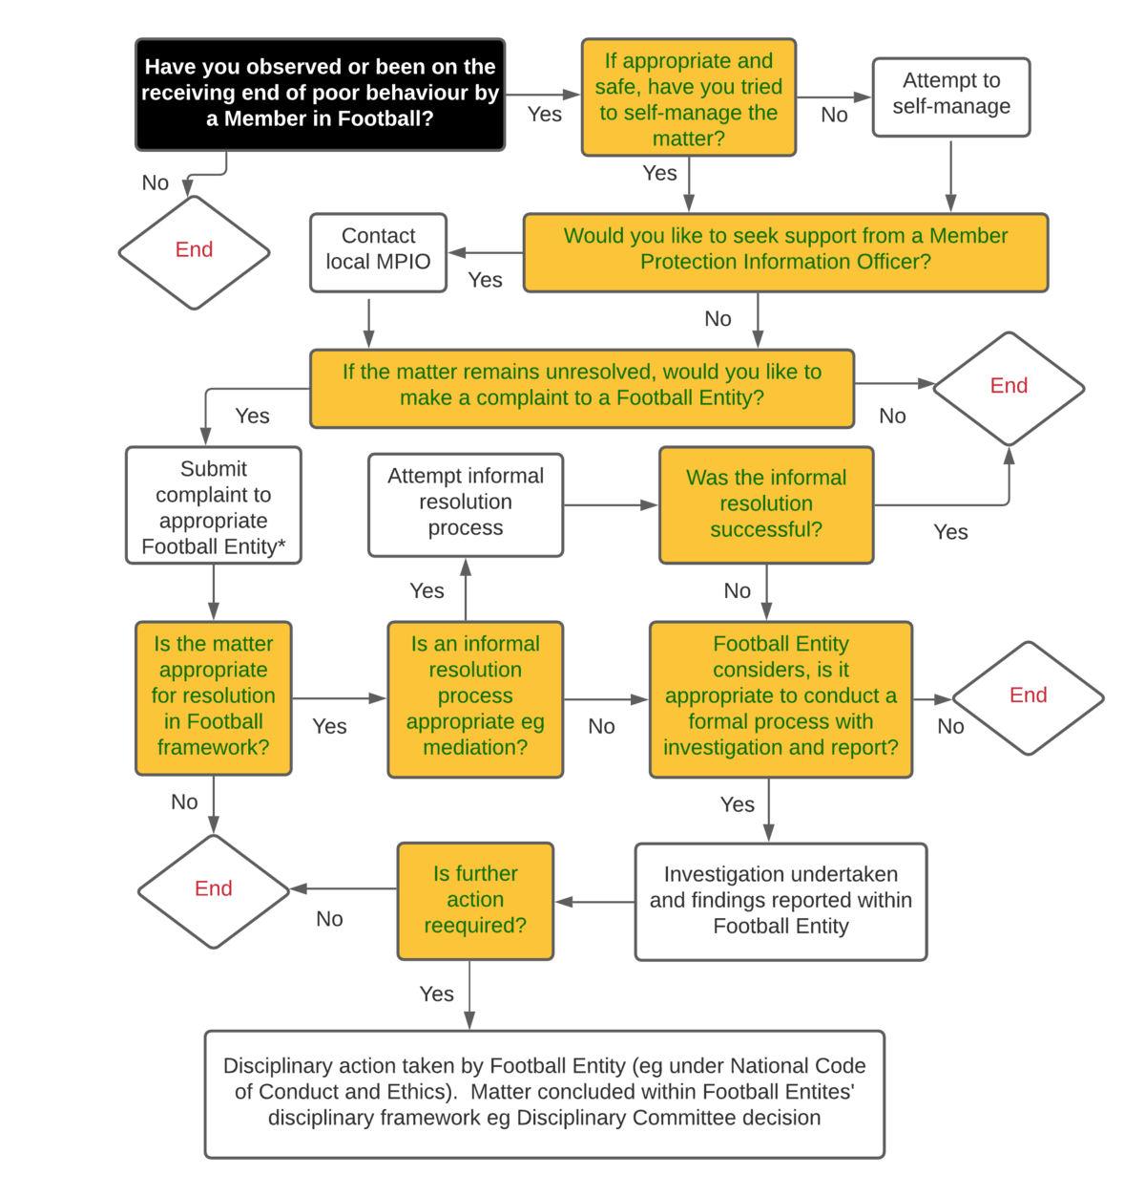

1. (_Club)
2. Football West: [Intergrity@footballwest.com.au](mailto:Intergrity@footballwest.com.au)
3. Football Australia : [HERE](https://landing.coreplusplatform.com/football-federation-australia-limited/U2FsdGVkX1i%3C3uh1XAUa3Pz4xNDeYZt+MymuDNyK+XfRxvlFbjq0as5fBwQQi%3C3uO6yCfV)

Source: Football Australia - https://www.footballaustralia.com.au/member-protection/complaints-procedure/flowchart

Lodge your complaint at the level at which the issue occurs (e.g. if it’s a club issue, then it should be dealt with at the local level via the club member protection officer; if it’s a state or national issue direct it to the appropriate authority):

If you have an urgent concern about the safety, health or welfare of a child, contact emergency services on 000. If you are a child or adult who has been the victim of child abuse, or if you have information about someone else being abused, you can contact police anytime on 131 444 and can request to speak to a member of the Child Abuse Squad.

If you have concerns for a child’s wellbeing, contact the Department of Communities on 1800 271 889 or Central Intake Team on 1800 273 889.

You can also contact either agency at any time during the complaint handling process. If you’re not satisfied with the way the complaint’s been handled or you’re unhappy with the outcome, you may be able to either lodge an appeal or direct the complaint to the next level (e.g. state or national organisation.)

**10.2 Further Guidance**

Use these tools for support and guidance:

* Making an Integrity Complaint or Report – Football Australia
* Complaints Process in 5 Steps – [SIA]
* Speak Up & Make a Complaint – National Office for Child Safety
* Complaints Handling in Sport – Play by the Rules (PBTR)

All complaints will be managed confidentially, respectfully, and in accordance with (_Club’s) procedures and the Football Australia Member Protection Framework.

**11. Empowering Children**

(_Club) actively promotes children's rights and participation by:

* Using child-friendly resources like "Your Rights at Sport"
* Encouraging children to express concerns or complaints
* Educating children about respectful relationships, boundaries, and protective behaviours
* Promoting confidence and empowerment in young players

**12. Continuous Improvement**

This policy will be reviewed at least annually, and after any reportable incident, in line with updates from:

* National Office for Child Safety
* Football West and/or Football Australia
* WA Government or legislative changes

(_Club) will also complete the annually. This self-assessment tool provides a structured way to review how well the club is meeting its safeguarding responsibilities in the following areas:

* Governance and culture
* Codes of conduct and expected behaviours
* Recruitment and screening
* Complaints and incident management
* Education and training
* Risk management

The results of the checklist will be reviewed by the Committee, with action items recorded and addressed as needed.

**13. References**

1. Football Australia *Safeguarding:*

<https://www.footballaustralia.com.au/member-protection/safeguarding>

1. Sport Integrity Australia (2022). *Child Safeguarding Checklist* (Self-Assessment Tool). Retrieved July 2025 from <https://www.sportintegrity.gov.au/sites/default/files/2022-10/Child%20Safeguarding%20Checklist.pdf>
2. Sport Integrity Australia (2021). *Safeguarding resources*. Retrieved July 2025 from <https://www.sportintegrity.gov.au/resources>
3. Sport Integrity Australia (2021). *Making an Integrity Complaint or Report*. Retrieved July 2025 from <https://www.sportintegrity.gov.au/contact-us/reporting>
4. National Office for Child Safety (2021). *Speak Up & Make a Complaint*. Retrieved July 2025 from <https://www.childsafety.gov.au/resources/speak-up-make-complaint>
5. Australian Human Rights Commission (2019). *National Principles for Child Safe Organisations*. Retrieved July 2025 from <https://childsafe.humanrights.gov.au>
6. Play by the Rules (2020). *Complaints Handling in Sport*. Retrieved July 2025 from <https://www.playbytherules.net.au/resources/complaints-handling>
7. Health Direct Australia (2023). *Child Abuse – Signs and How to Help*. Retrieved July 2025 from <https://www.healthdirect.gov.au/child-abuse>
8. Australian Institute of Family Studies (2022). *Pre-employment Screening: Working with Children Checks and Police Checks*. Retrieved July 2025 from <https://aifs.gov.au>